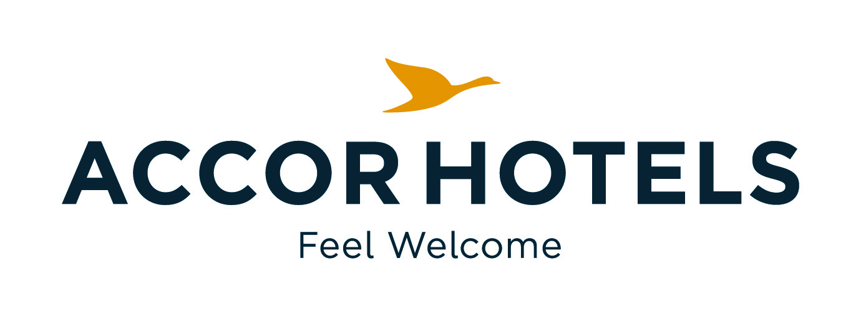
ibis budget Ambassador Busan Haeundae
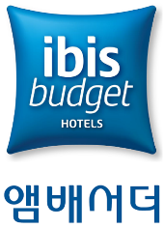

ibis budget Ambassador Busan Haeundae Registration Form

ISPCM

- Room Type / Room Rate (Room only) / Period 14th March and 22nd March, 2018
Room Type | Bed Type | Convention Rate | Room Size | Remark | Choice
Standard Double(City) | 1Double | 55,000 | 13.88㎡ | 10% TAX Included
Standard Twin(City) | 2 Single | 60,500 | 15.8㎡ | 10% TAX Included
Standard Twin(Ocean) | 2 Single | 71,500 | 15.8㎡ | 10% TAX Included

- Breakfast
No. | Name of restaurant | Location | Menu | Price | Remark | Choice
1 | La Matine | Lobby | Buffet | 12,100KRW  (Per Pax) | 10% TAX Included

Please fill out this registration form and send it to h9106-re@accor.com(mandatory)
Name : | Country :
Phone Number : | E-mail :
Check In & Check Out date :
Breakfast(12,100KRW) : ( ) No. of pax
Remark

- Payment Information (mandatory)
Credit card Type & Number: | Expire date :

- Cancellation Policy
- If cancelled or modified up to 7-6 days before the date of arrival, 50 % of the 1 night will be charged.
If cancelled or modified up to 5-4 days before the date of arrival, 100 % of the 1 night will be charged.
If cancelled or modified up to 3 days–on check-in date or in case of no-show, all night room rate will be charged.
- Early Checkout will be also charged 100% the rest of duration reserved.
If you cancel or no-show, cancellation fee will be charged automatically with the above credit card without further notice.

